**Agile Scrum**

Q1) Make a product backlog of user stories for the given case study. User Stories should be in the format of As a <type of user>, I want <goal> so that <reason>

Ans) These are some of the **product backlog** of the user stories for the given case study:

1. As a user,I want ABC Pantry feature to be visible inside the ABC Website so that the sales of the ABC Website increases gradually
2. As a user,I want ABC Pantry to be clickable so that it would open a new range and categories of Product to various customers
3. As a user,I want ABC Pantry to be visible inside app also so that customers can use it according to their convenience
4. As a user,I want daily essential items to be added in ABC Pantry so that there is a logical grouping of products
5. As a user,I want categories of Flour and Rice to be included so that customers can search and buy it according to their requirement
6. As a user,I want categories of sugar,salt and spices has to be added so that customers can search and buy them according to their need
7. As a user,I want categories of pulses has to be added so that customers can purchase these pulses according to their need and requirement
8. As a user,I want categories of Personal Care has to be added so that customers can purchase these items
9. As a user,I want categories of snacks to be added so that customer can purchase these snacks
10. As a user,I want categories of Hand Wash and Sanitizers has to be added so that customers can purchase these items
11. As a user,I want categories of Breakfast food items has to be added so that customer can purchase these items
12. As a user,I want various categories of Tea and Coffee has to be added so that customers can purchase these items with ease
13. As a user,I want various categories of Baby Care has to be added so that customers can purchase these items
14. As a user,I want various female hygiene items has to be added so that customers can search and purchase these items
15. As a user,I want Tissue and Freshners to be added in daily essential category for purchase
16. As a user,I want five advertisments has to be added in ABC Pantry so that there is huge adds revenue
17. As a user,I want certain offers has to be added in ABC Pantry so that customers can buy the products under these offers
18. As a user,I want various items including non-essential products has to be added in shopping cart so that customers can do shopping with ease
19. As a user,I want that software should not allow the user to place an order of an amount less than 30 USD so that a minimum threshold purchase amount is maintained for all customers
20. As a user,I want free delivery will be offered only if the total order exceeds 50USD so that a more and more customers will get attracted in this offer
21. As a user,I want view reports section has to be visible so that Management can view the reports at the end of the day

The below mentioned are the screenshots of the **product backlog:**

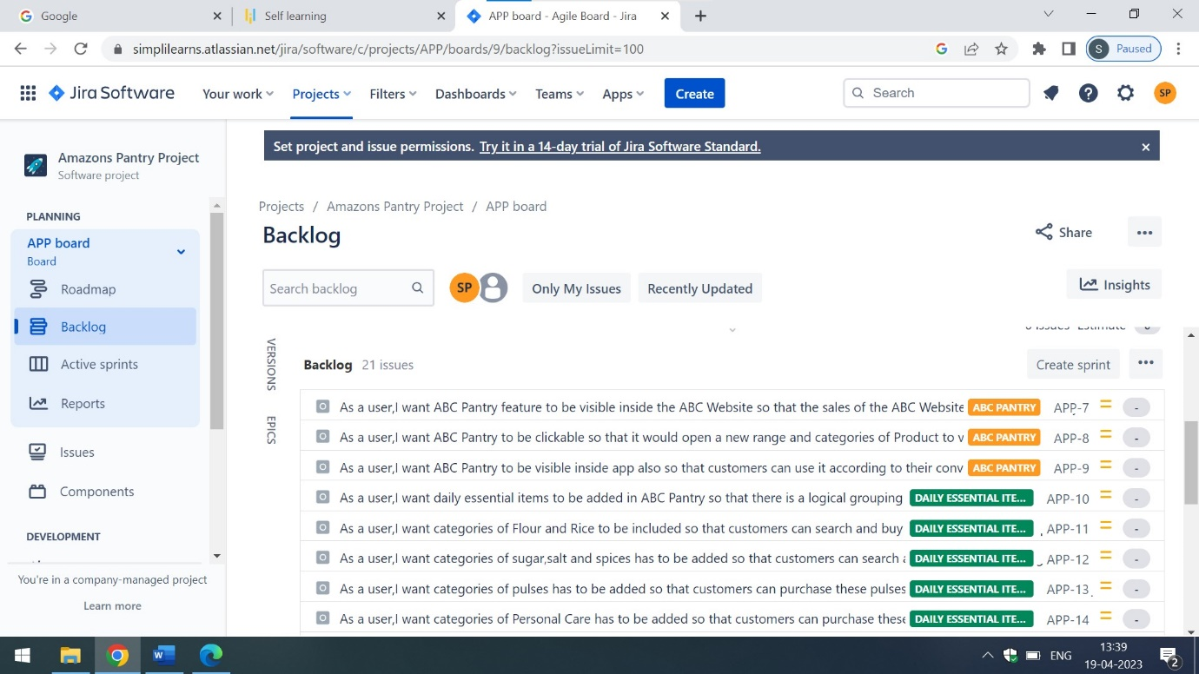

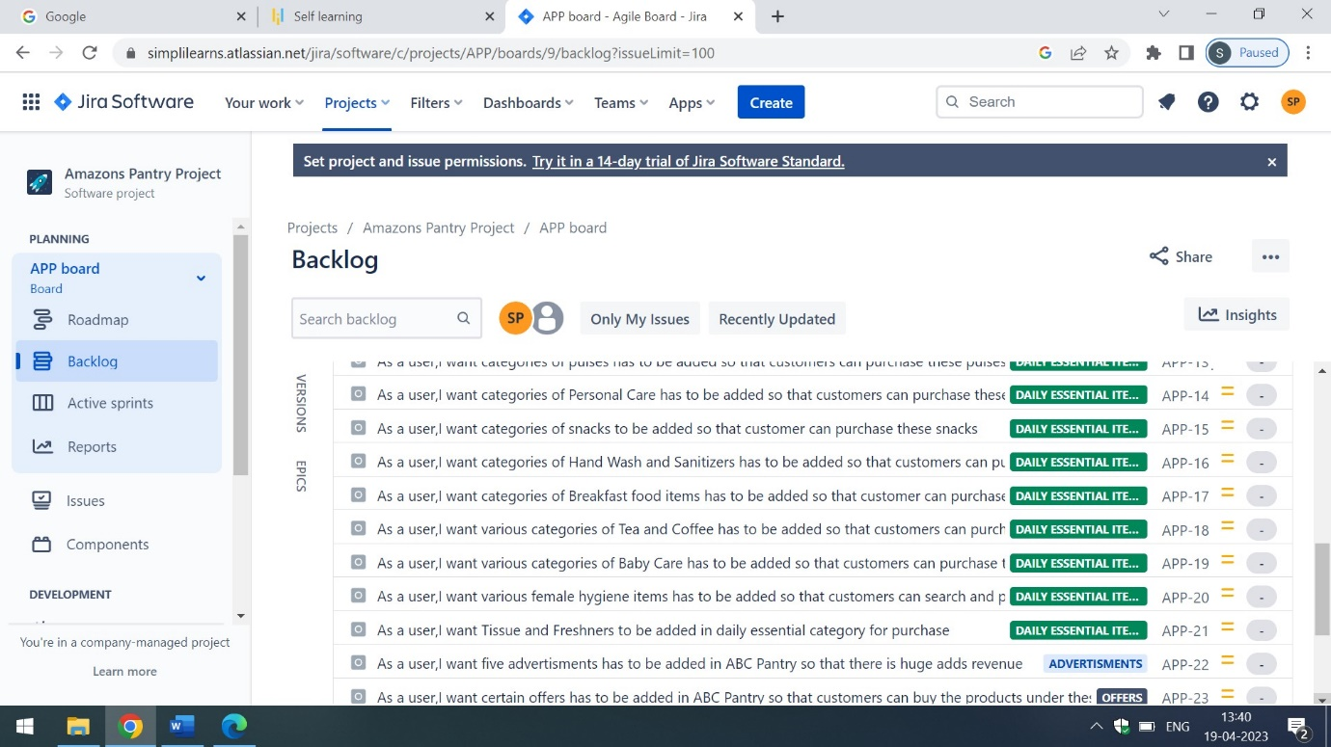

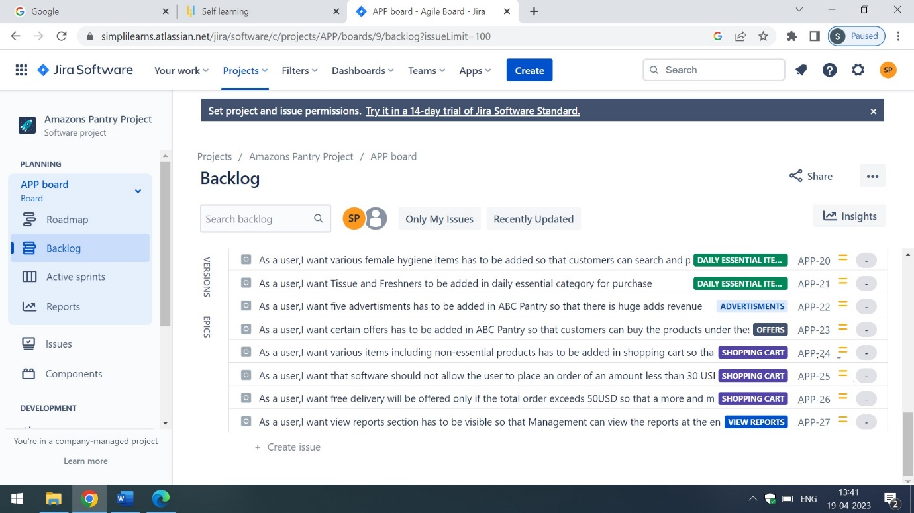

Q2) For each story, write the acceptance criteria.

Ans) These are the **acceptance criteria** of ABC Pantry Page

a)User must be able to perform single and double click on ABC Pantry tab

b)When the user clicks on the ABC Pantry tab a detailed view of daily essential products list must be visible to the users

c) User must be able to login to the ABC website app(which contains the ABC Pantry) also in the mobile apps

These are the **acceptance criteria** of **Daily Essential Items Page**

1. The daily essential items must include the following categories which includes the Flour and Rice,Sugar,Salt and Spices,Pulses,Personal Care,Snacks,Hand Wash and Sanitizers,Household cleaning essentials,Breakfast food items,Tea and Coffee,Baby Care,Female Hygiene as well as Tissue and Fresheners
2. The categories of Flour such as Bread Flour,Whole Wheat Flour,White Whole Wheat Flour,Cake Flour and Pastry Flour has to be there in Flours section
3. The categories of rice such as Arborio Rice,Basmati Rice,Black rice,Bomba Rice,Brown rice,Jasmine rice,Long Grain White Rice and Parboiled rice has to be added in rice categories
4. Customers can select multiple or singular flour and rice items according to their requirement
5. The various categories of sugar such as white,brown and liquid sugars has to be there in sugars category
6. The various categories of salt such as table,kosher,pickling,Himalayan Pink,Black and Sea Salt has to be added in salt category
7. The various categories of spices such as Allspice,Anise,Cardamom,Chinese five spice,Cinnamon,Cloves,Coriander and Cumin has to be added in spices category
8. Customers can select various salt,sugar and spices according to their needs and requirements
9. The various types of Pulses such as split and skinned green gram,green gram,black eyed beans,split red lentils,Indian Brown lentils,yellow pigeon peas,kidney beans and green peas has to be added in Pulses categories
10. Customers can select single or multiple pulses according to their need
11. The various types of Personal Care products such as cleansing pads, colognes, cotton swabs, cotton pads, deodorant, eye liner, facial tissue, hair clippers, lip gloss, lipstick, lip balm, lotion, makeup, hand soap, facial cleanser, body wash, nail files, pomade, perfumes, razors,shaving cream, moisturizer and baby powder has to be added in Personal Care Category
12. Customers shall be able to select multiple or single products according to their requirement
13. The various types of snacks such as Potato chips,tortilla chips,corn chips,ready to eat popcorn,extruded snacks,pretzels,snack nuts, meat snacks, pork rinds, party mix, multigrain chips, granola products, and variety packs has to be added in snacks categories
14. Customers shall be able to select single or multiple snacks according to their requirements
15. The various types of Personal Care products such as cleansing pads, colognes, cotton swabs, cotton pads, deodorant, eye liner, facial tissue, hair clippers, lip gloss, lipstick, lip balm, lotion, makeup, hand soap, facial cleanser, body wash, nail files, pomade, perfumes, razors,shaving cream, moisturizer and baby powder has to be added in Personal Care Category
16. Customers shall be able to select multiple or single products according to their requirement
17. The various categories of Hand Wash such as Dettol,LifeBoy,Palmolive and Fiama di wills has to be added in Hand Wash Categories
18. The various types of Sanitizers such as Savlon,LifeBoy,Dettol and Purell has to be there in Sanitizers Categories
19. Customers can select multiple and single Hand Wash and Sanitizers according to their needs and requirements
20. The various types of Breakfast such as Sausage,French Toast,Breakfast Sandwich,Breakfast wrap,cereal,Home Fries,Avocado Toast,Chicken and Waffeles,Pancakes and Bacon has to be added in Breakfast Categories
21. Users can select single or multiple breakfast items according to their need and requirements
22. The various types of tea such as Black Tea,Green Tea,Oolong Tea,White Tea,Yellow Tea,Herbal Tea and Yerba Mate has to be added in tea categories
23. The various types of coffee such as Espresso,Latte,Cappuccino,Flat White,Frappe,Mocha and Americano has to be there in coffee lists
24. Customers can purchase various types of tea and coffee according to their need and requirement
25. The various types of Baby Care items such as Baby Swing,Baby Bouncer,Toys,Bottles has to be added in Baby care categories
26. Customers can select multiple or single baby items according to their needs and requirement

These are the acceptance criteria of **Advertisements** Page

1. The ABC Web Page must include atleast 5 advertisments for better revenue generation
2. The adds must appears as a slideshow in a sequential manner to the user of ABC Web Page
3. The advertisements shall contain the latest videos of Daily Essential Items along with caption in English

These are the acceptance criteria of **Offers** Page

1. The ABC web page must have some latest offers related to daily essentials such as buy1 get 1 free or 30% discount on purchase of two
2. The customers must be notified with the message service in case of new offers on daily essentials

These are the acceptance criteria of **Shopping Cart** Page

1. The shopping cart has to be of trolly symbol and must be white in color
2. User shall be able to add multiple or single items of daily essentials and even non-essentials for their purchase
3. The place order button has to be present below the shopping cart and must be clickable which redirects the user to the checkout page
4. The software shall generate an error message for the orders less than 30USD
5. The price tags must be associated in dollar notation such as 20USD or 60USD for the items which are listed in Daily Essentials
6. Customers of the listed cities shall be able to edit the items prior to checkout
7. Customers of the listed cities gets notification of free delivery on their email id and on text messages if the total order exceeds 50USD
8. Delivery charge of 10 USD will be added in the shopping cart if the order is less than 50 USD

These are the acceptance criteria of **View Reports** Page

1. The Permission of Viewing Reports is accessible to ABC Management only
2. When the user clicks on the viewing reports section in the ABC Website, a detailed drop down will appear which contains the information related to

-Total sales for each day

- Total sales for each product category

- Total sales across USA

- Total sales for each city

- Total sales for each zone that city falls into (that is, zone 1, 2, 3, and 4)

- Identification of best selling categories

- Identification of worst selling categories

- Total sales of each week city wise

- Identifying which day of the week shows highest booking by the customers

Here are the attached screenshots of the above mentioned acceptance criteria of user stories

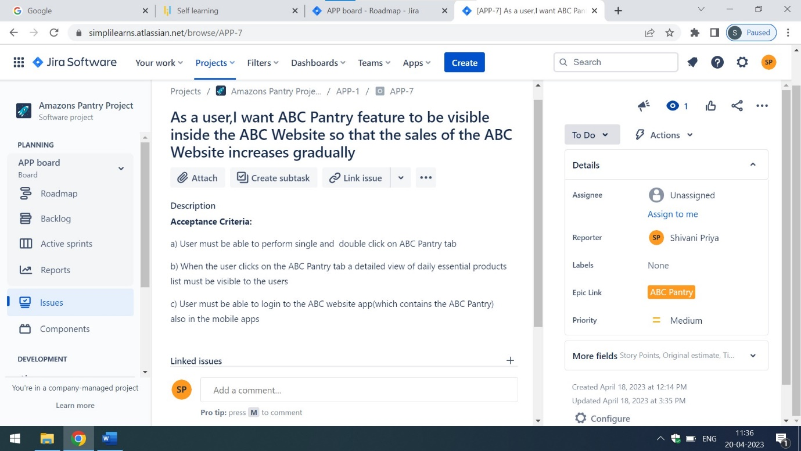

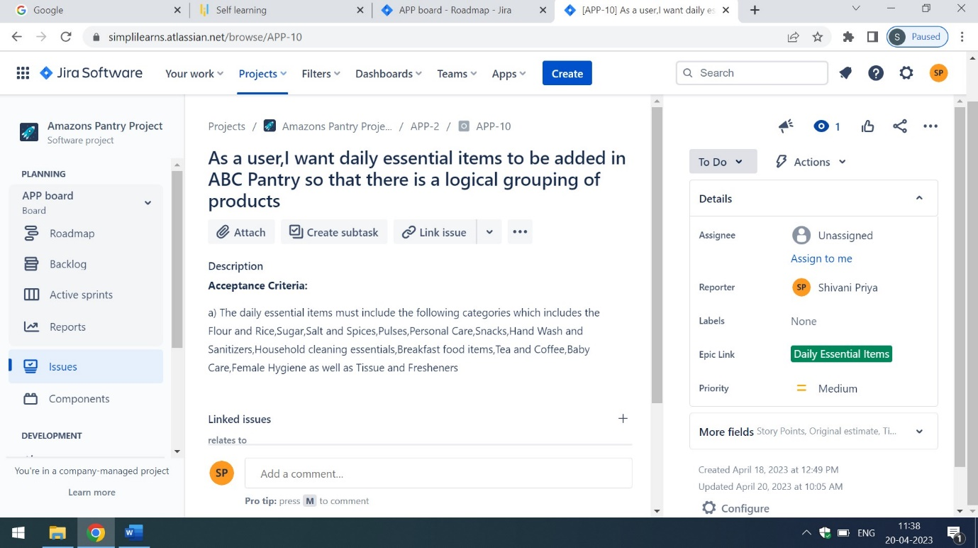

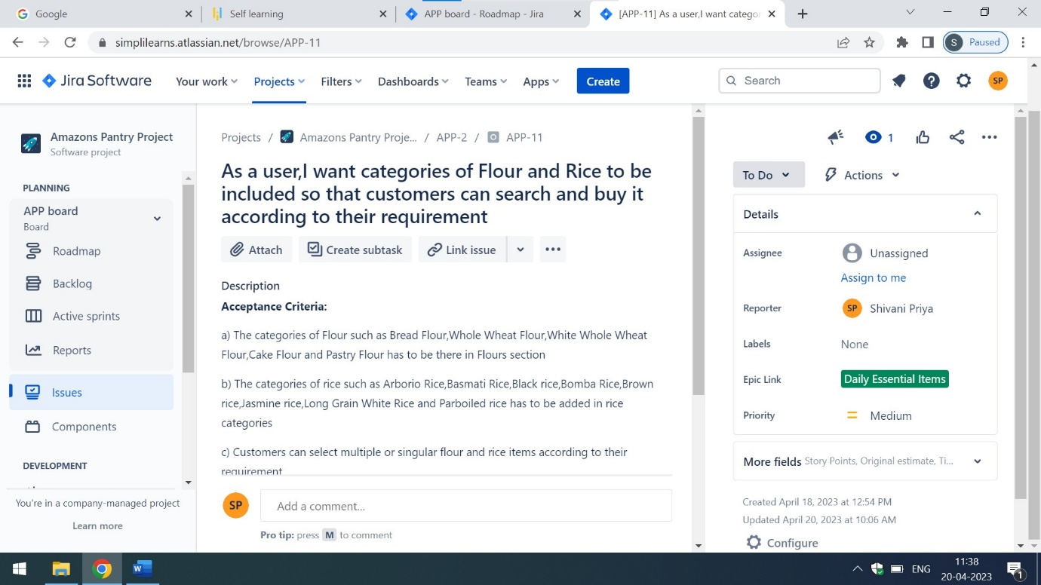

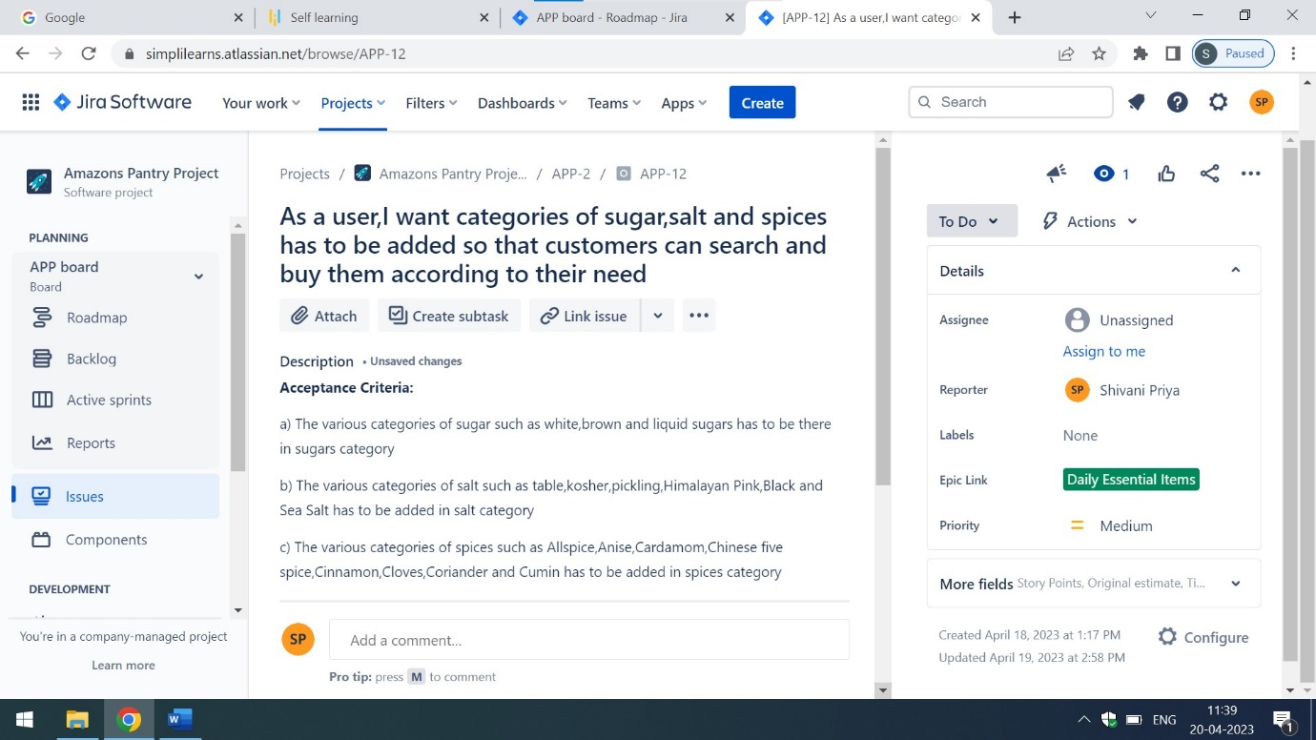

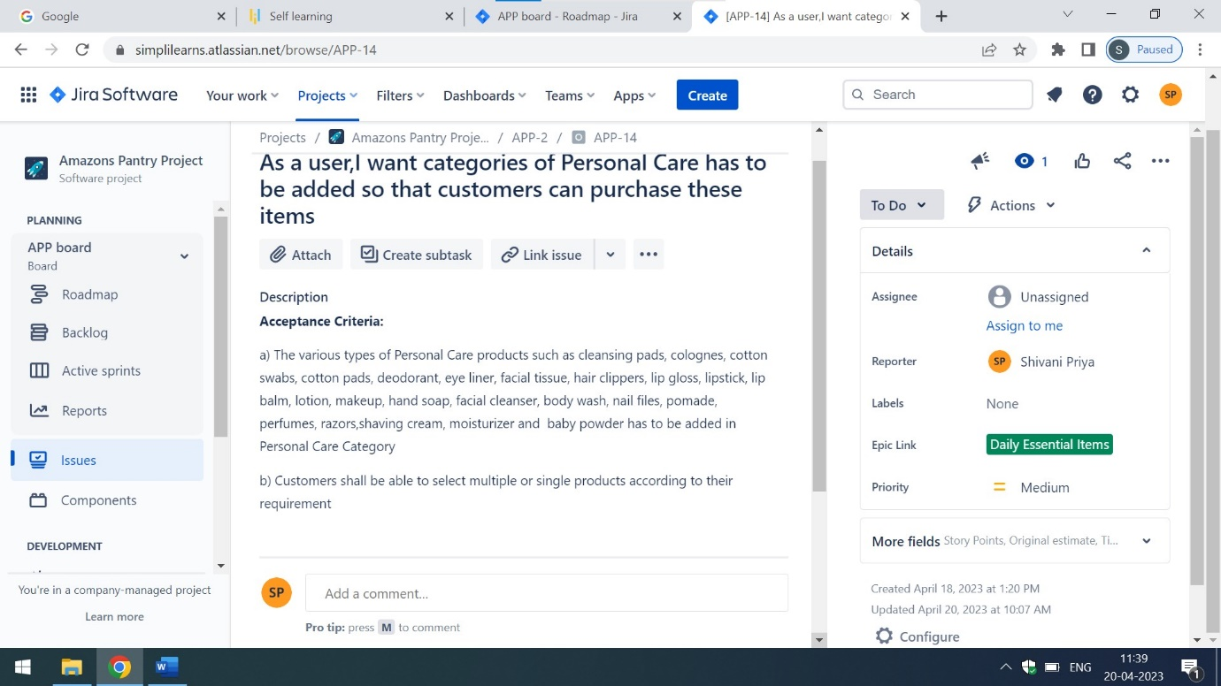



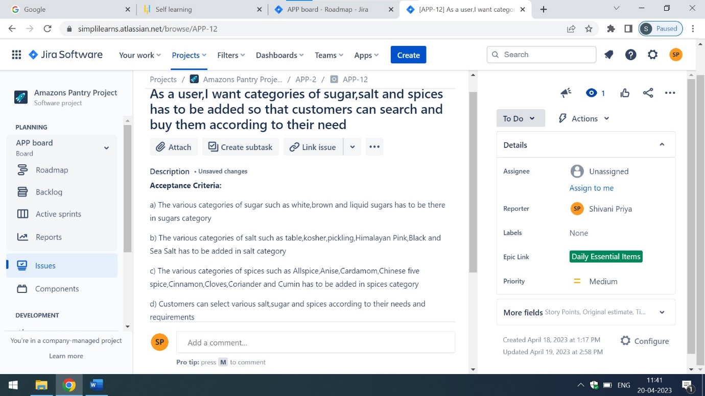

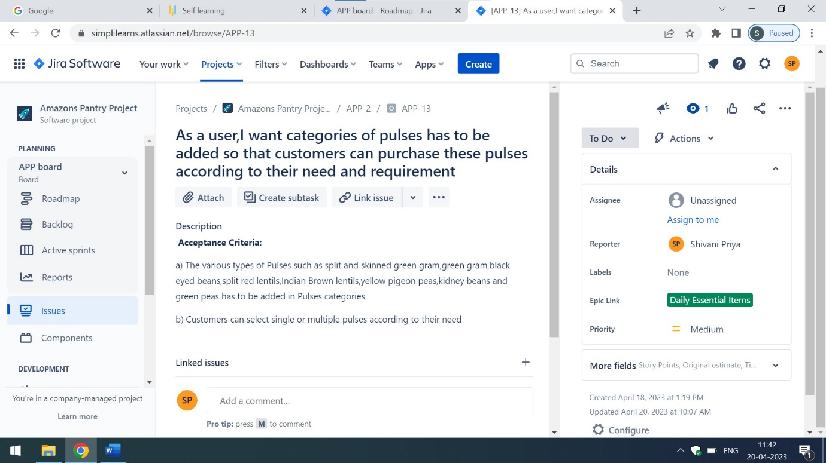

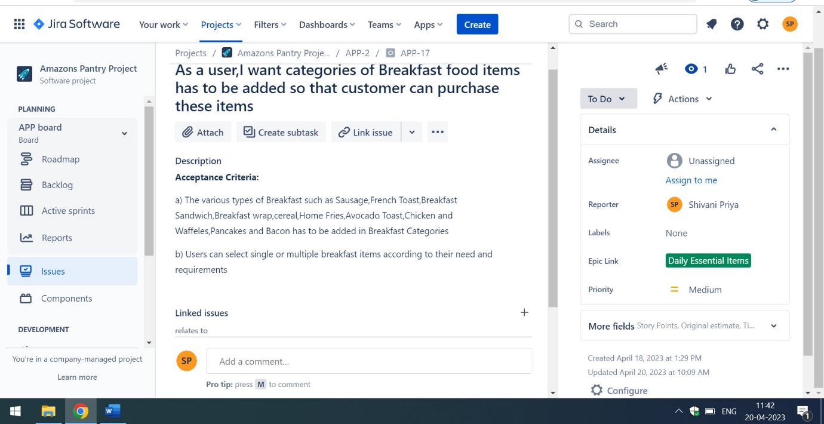

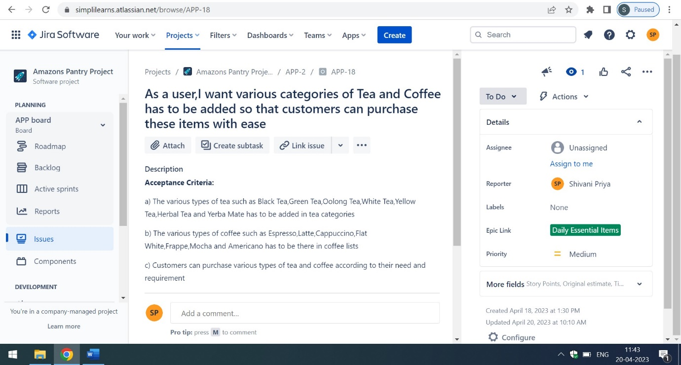

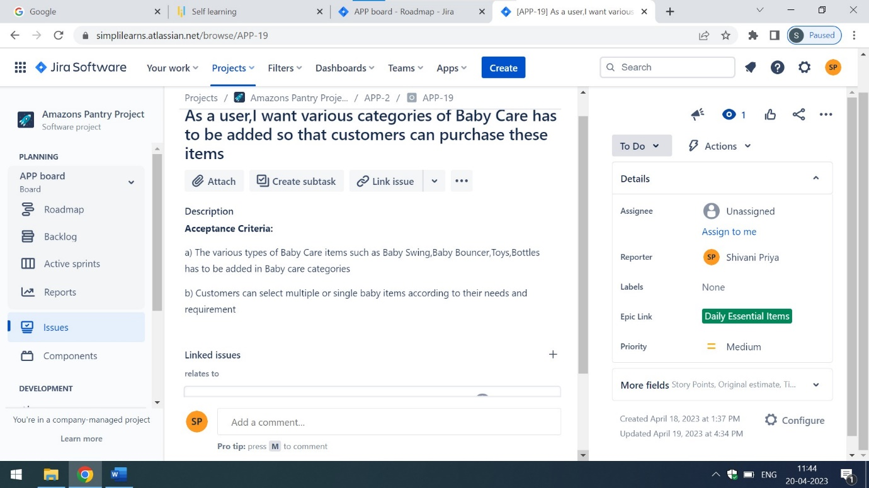

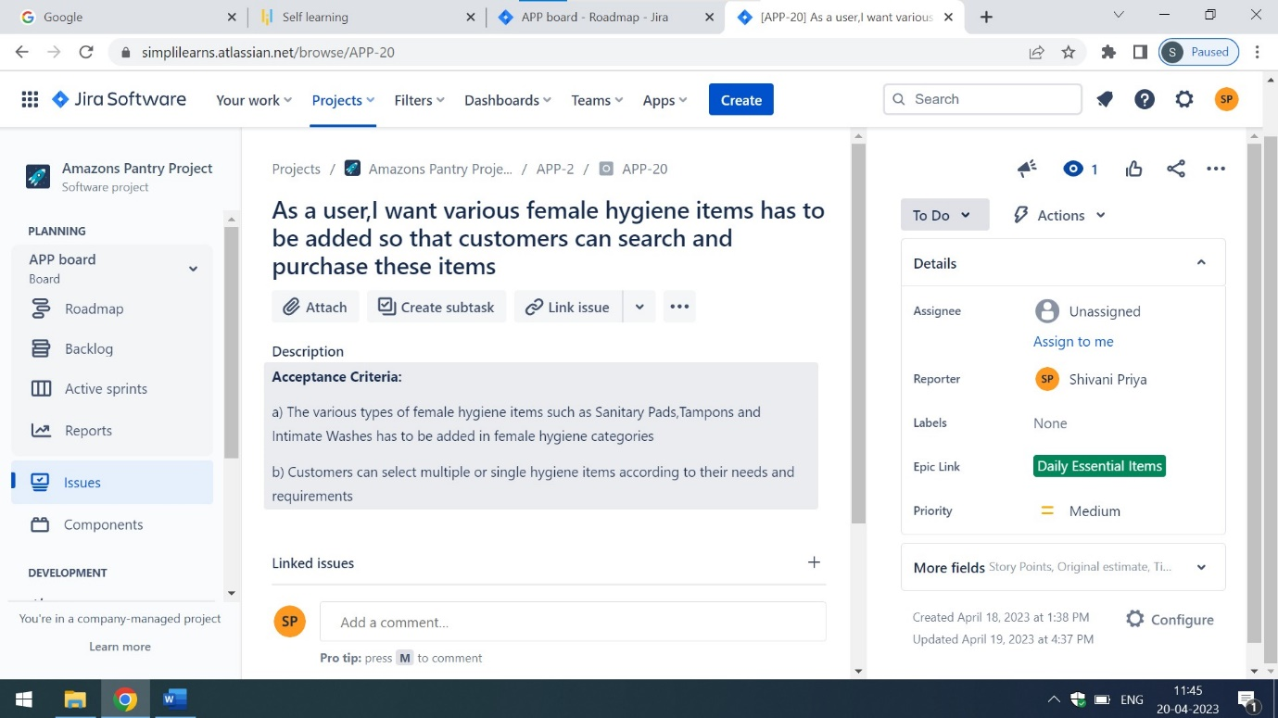

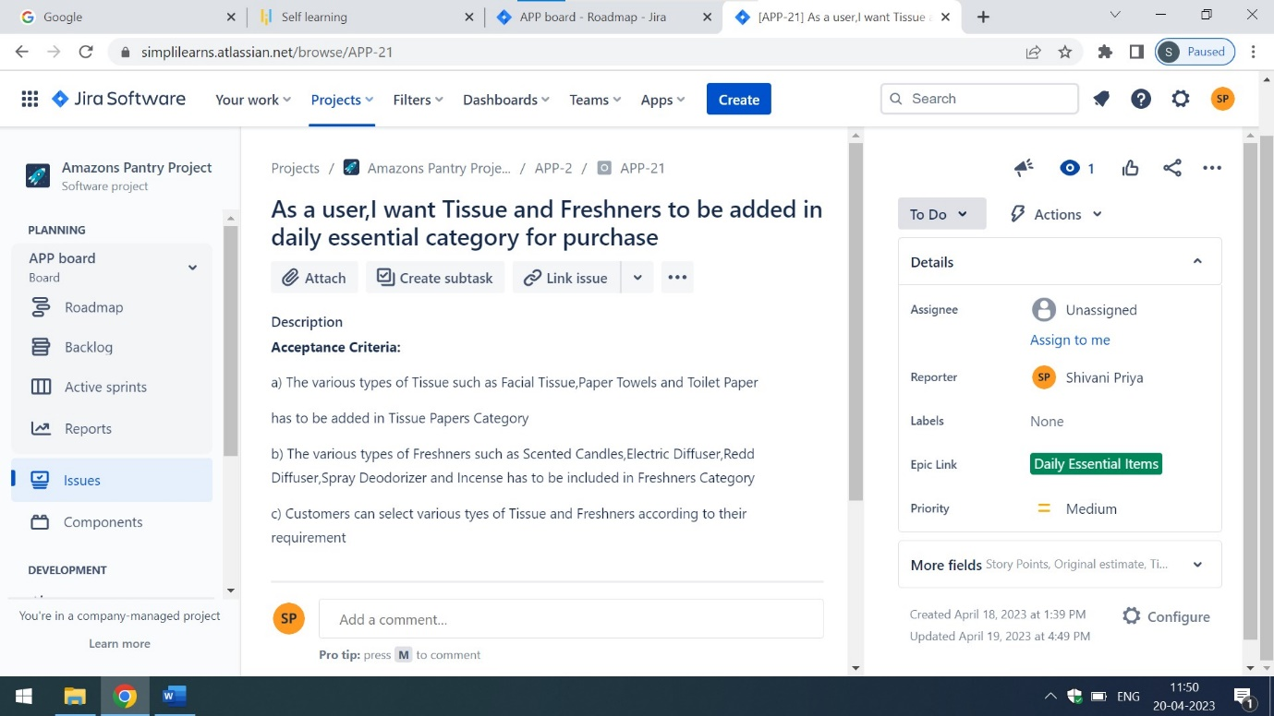

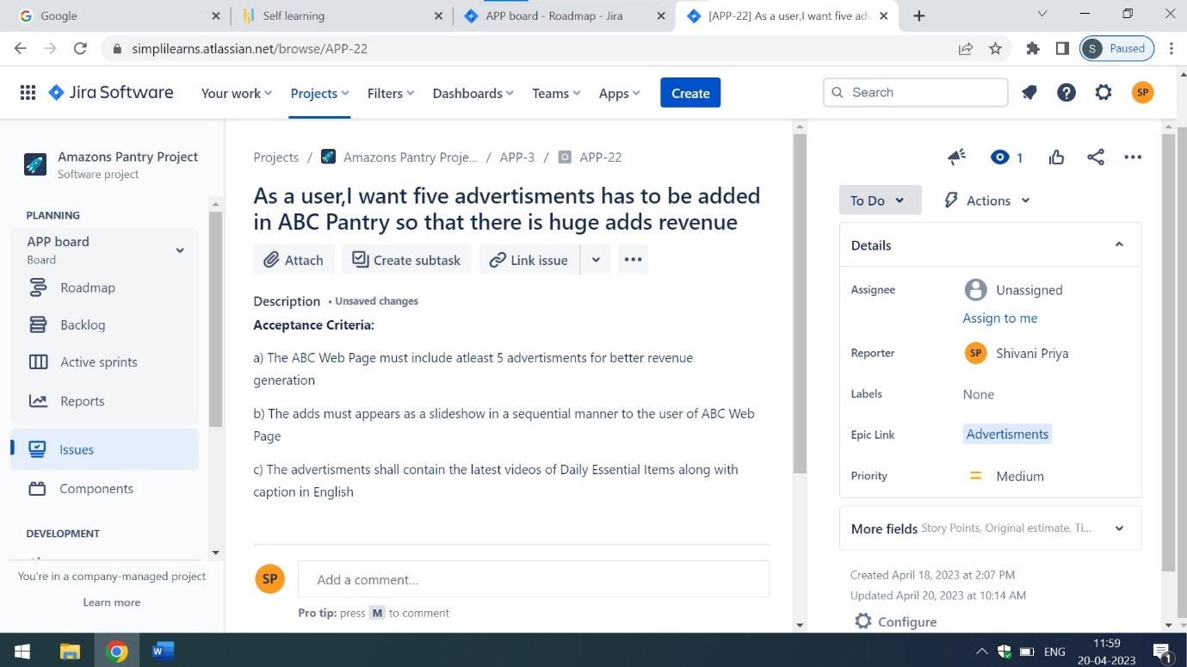

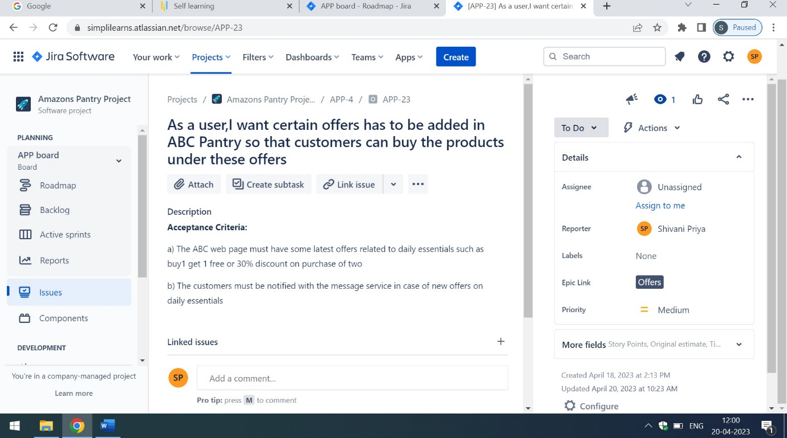

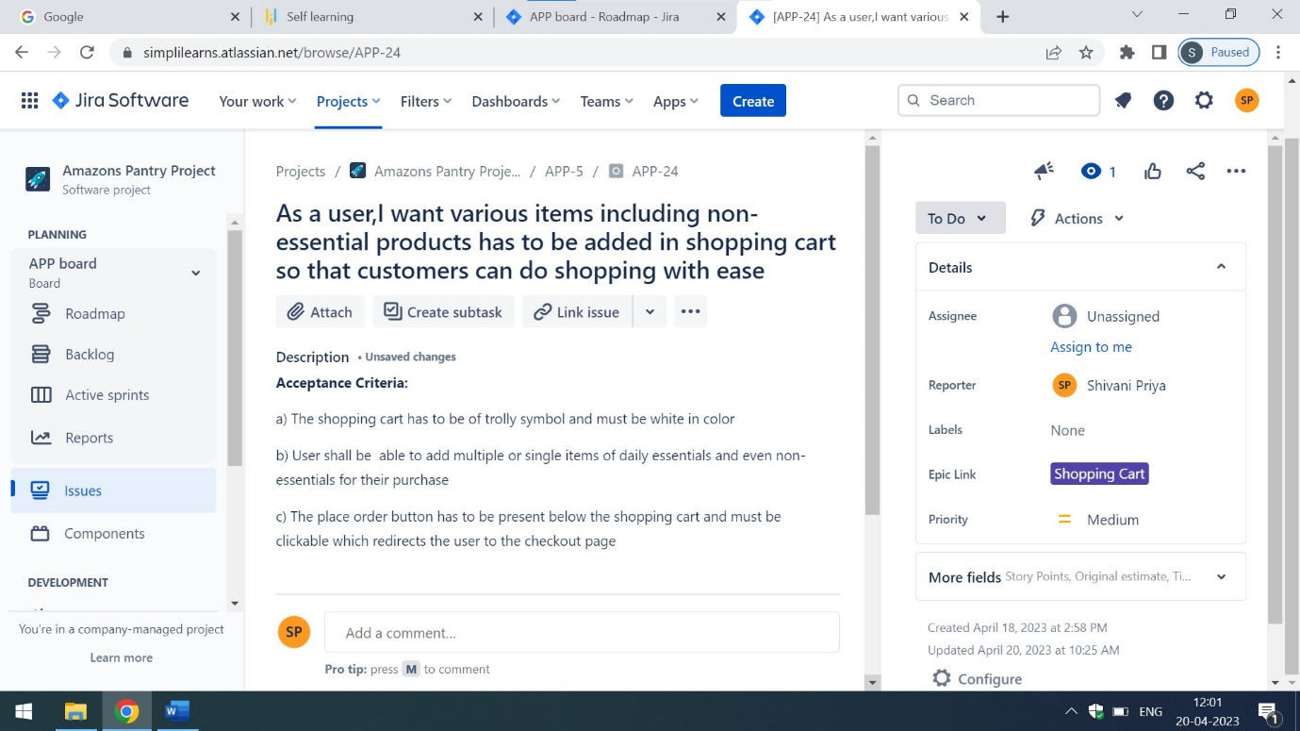

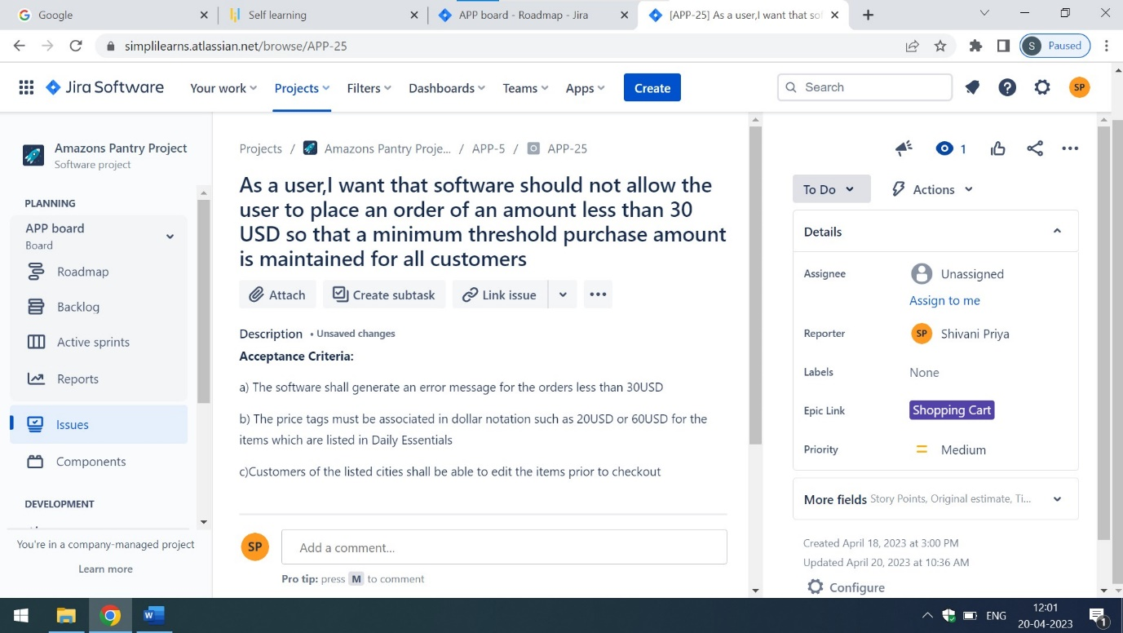

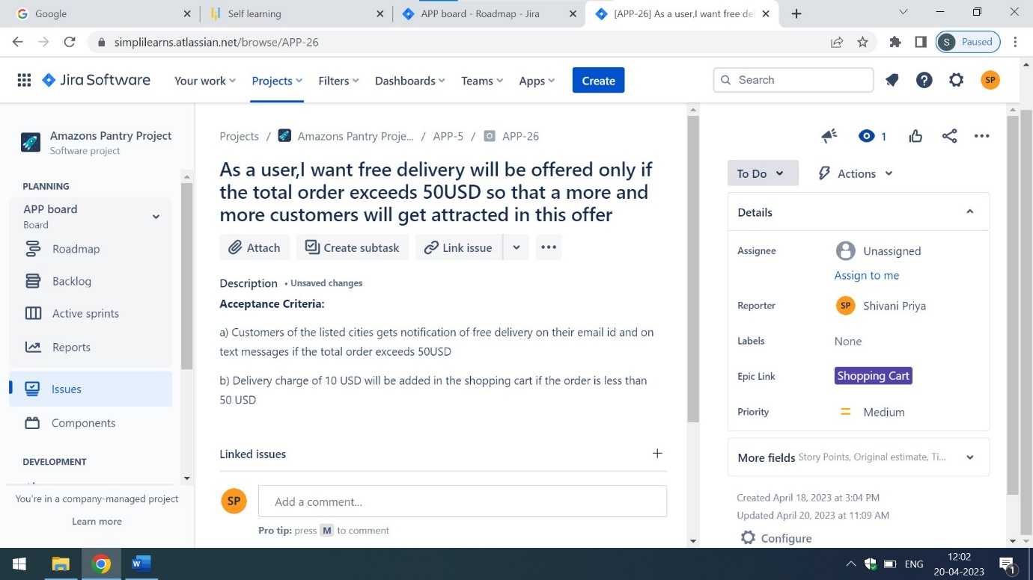

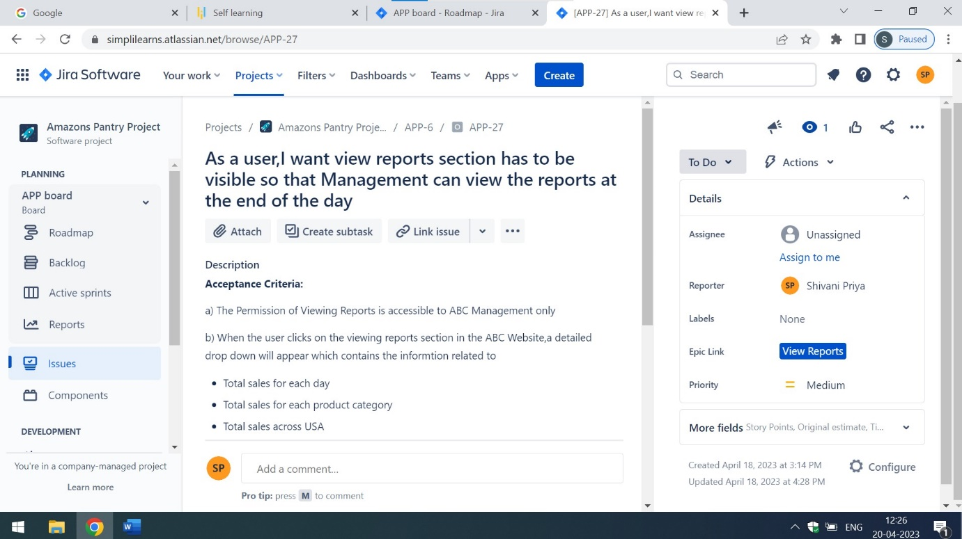

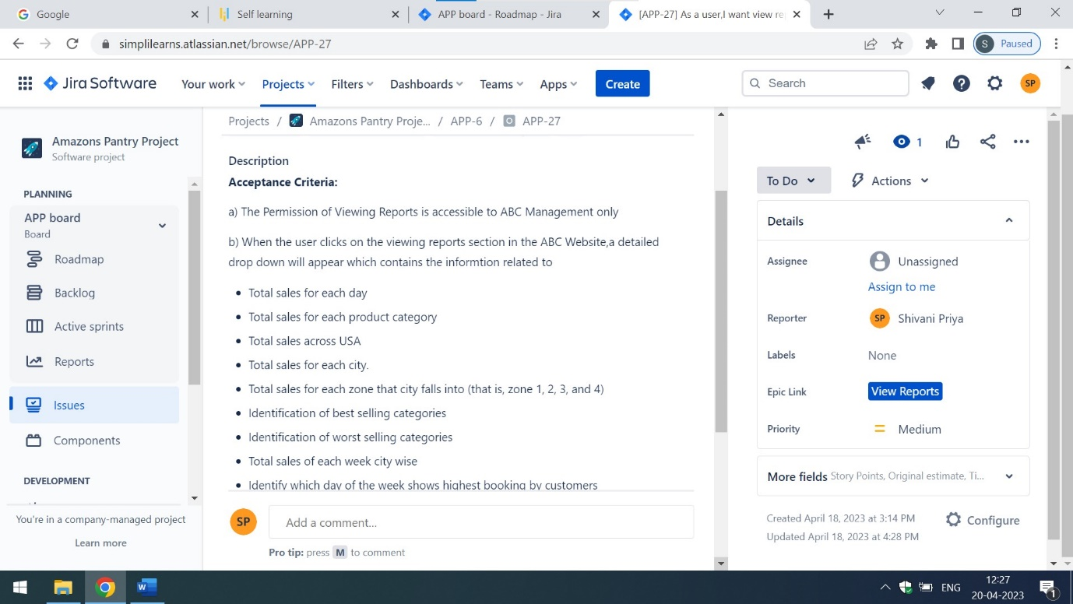

For detailed description of epics,user stories and Acceptance Criteria of Amazon Pantry Project click on the below mentioned link:

<https://simplilearns.atlassian.net/jira/software/c/projects/APP/boards/9/roadmap>